

ST10487205

Ntokozo Nhlakanipho Zulu

Web Development Project Proposal

WEDE5020

**Table of Contents**

Organization Overview……………………………………………………………………..3

Website Goals and Objectives……………………………………………………………………..4

Proposed Website Features………………………………………………………………………..4

Design and User Experience……………………………………………………………………….5

Technical Requirements………………………………………………………………………….....6

Timelines and Milestones…………………………………………………………………...………6

Budget………………………………………………………………………………………………...6

Site Map………………………………………………………………………………………………7

Bibliography/Reference List………………………………………………………………………...8

**Organization Overview**

**Name**

DevNest Academy

**Brief History**

DevNest Academy is an online platform designed to offer aspiring software developers access to training and teaching in today’s most in-demand programming languages. The website will allow potential students to browse available courses, learn about the academy, and **submit applications** to enrol in training programs. It will serve as a gateway for beginners and intermediate learners to gain practical skills in languages such as Python, JavaScript, Java, and others.

**Mission and Vision Statements**

DevNest Academy aims to make quality programming education accessible to all by offering hands-on training in today’s most in-demand programming languages. Our vision is to empower aspiring developers with the skills, confidence, and support needed to thrive in the tech industry and contribute meaningfully to the digital future.

**Target Audience**

Our target audience includes aspiring developers, students, and career changers seeking practical training in modern programming languages to gain job-ready skills and break into the software development industry.

**Website Goals and Objectives**

**Specific goals for the website**

The main goal of the DevNest Academy website is to provide an accessible platform where users can explore programming courses and apply for training in current, high-demand programming languages. It aims to promote digital literacy, support career development, and simplify the application process for aspiring developers (Shelly & Rosenblatt, 2012). The site will focus on usability, responsiveness, and clarity of information.

**Key Performance Indicators (KPIs)**

Key performance indicators (KPIs) for the DevNest Academy website include the number of course applications submitted, user registration rates, and website traffic. Additional KPIs involve user satisfaction through feedback forms and mobile responsiveness metrics (Chaffey & Ellis-Chadwick, 2019). These indicators will help measure the website’s effectiveness in attracting and engaging aspiring developers.

**Proposed Website Features**

The DevNest Academy website will feature a user-friendly interface with key sections such as course listings, an online application form, instructor profiles, and a responsive contact page. Additional features include search functionality, testimonials, and mobile compatibility to enhance accessibility and user engagement (Pressman & Maxim, 2015). These elements aim to create a seamless and informative user experience.

**Design and User Experience**

The DevNest Academy website will adopt a sleek black, white, and neon green colour scheme to reflect a modern, tech-oriented aesthetic. The typography will resemble coding fonts to align with the programming theme, enhancing visual identity. A formal yet welcoming layout will ensure intuitive navigation and accessibility. Design will prioritise clarity, responsiveness, and user-friendliness to support user engagement and learning (Krug, 2014).

**Wireframes**

**Technical Requirements**

The website needs secure hosting with good speed and a custom domain name that matches the brand. It will be built using HTML for structure, CSS for styling, and JavaScript for interactive features (Duckett, 2014; Freeman & Robson, 2019). These tools ensure the site looks good, works well, and is easy for visitors to use.

**Timelines and Milestones**

The project timeline includes the proposal submission on 08 August 2025, followed by Part 1 due on 27 August 2025. Part 2 is scheduled for submission on 26 September 2025. The Portfolio of Evidence, which marks the final phase of the project, the submission date has not yet been disclosed. Each milestone allows for focused progress and timely completion of the photography website.

**Budget**

**Estimated Budget**

* **Domain name registration:** R150 – R250/year
* **Web hosting (basic shared hosting):** R600 – R1,200/year
* **Website development (student project):** R0 (self-developed)
* **Premium template or design assets (optional):** R500 – R1,000
* **SSL certificate (security):** Free – R400/year
* **Maintenance and updates:** R1,000 – R2,000/year
* **Marketing & SEO tools (optional):** R500 – R1,500

**Estimated Total**: R2 750 – R6 350 per year  
Costs may vary depending on service providers and project complexity (Chaffey & Ellis-Chadwick, 2019; Kotler et al., 2017).

**Site Map**

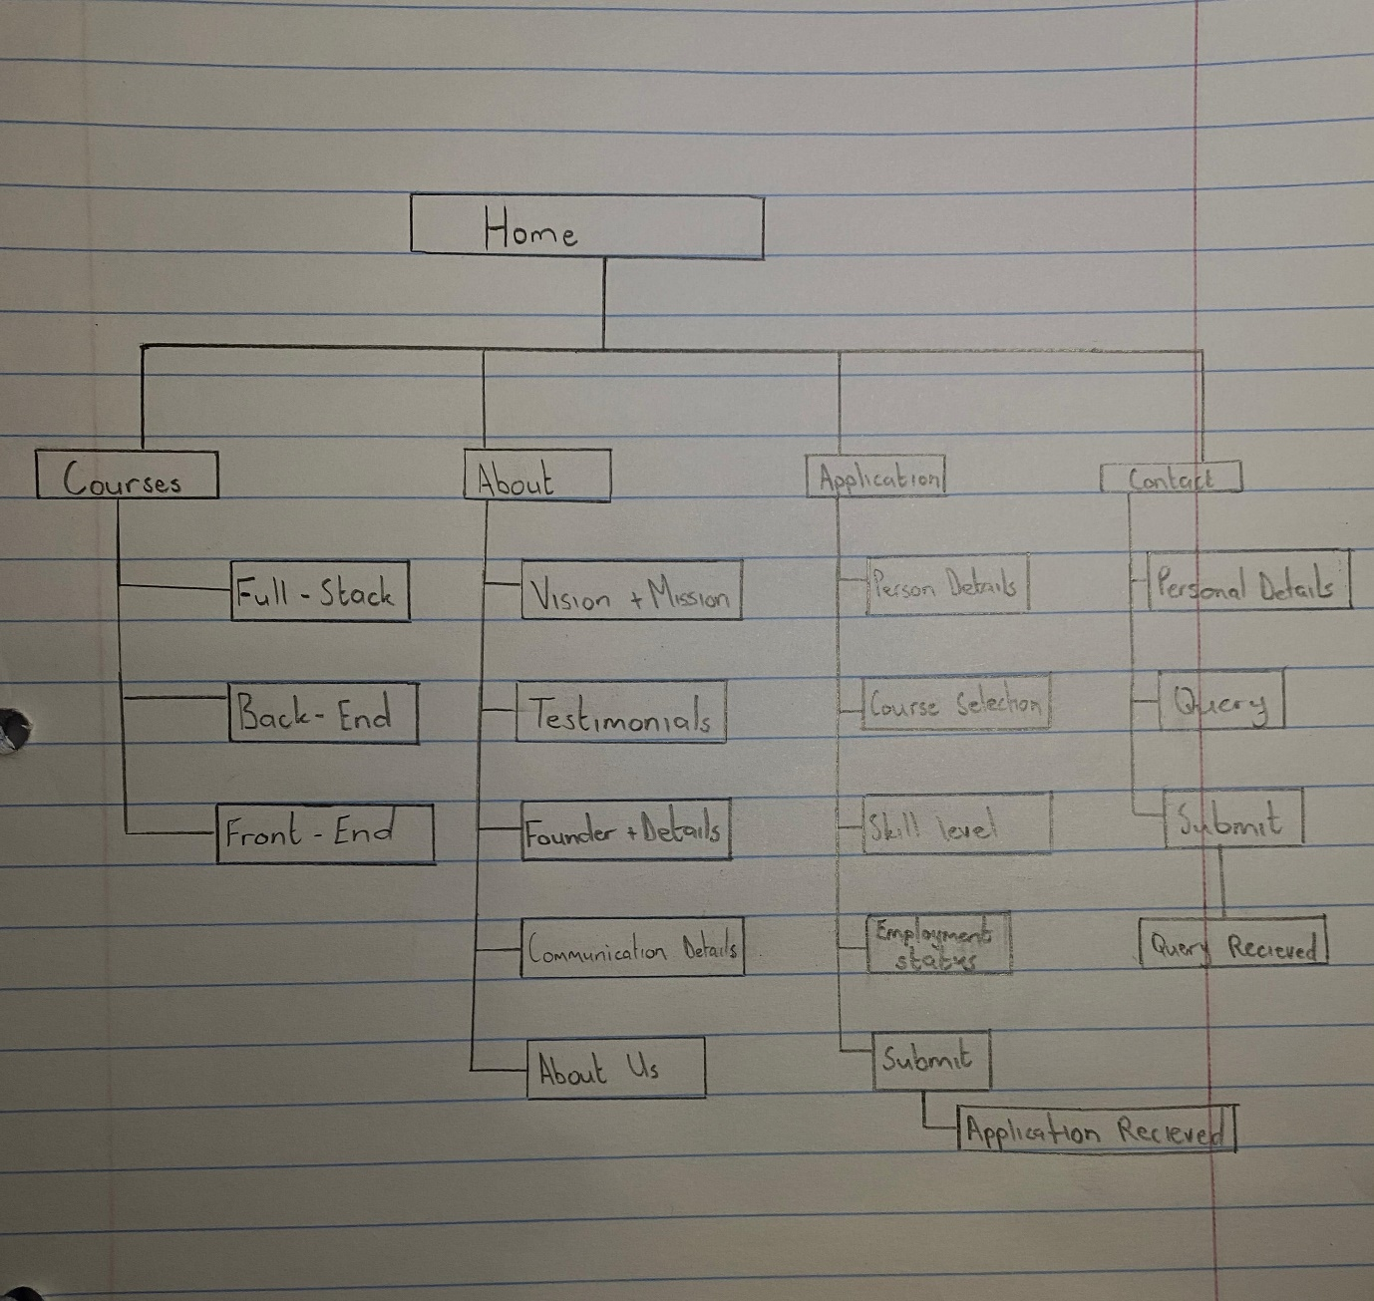

**Bibliography/Reference List**

Chaffey, D. & Ellis-Chadwick, F., 2019. Digital Marketing. 7th ed. Harlow: Pearson

Krug, S., 2014. Don't Make Me Think, Revisited: A Common Sense Approach to Web Usability. 3rd ed. Berkeley: New Riders

Shelly, G. B., & Rosenblatt, H. J. (2012). Systems Analysis and Design (9th ed.). Cengage Learning

Pressman, R. S., & Maxim, B. R. (2015). Software Engineering: A Practitioner's Approach (8th ed.). McGraw-Hill Education

Duckett, J., 2014. HTML and CSS: Design and Build Websites. Indianapolis: Wiley  
Freeman, E. & Robson, E., 2019. Head First JavaScript Programming. 2nd ed. Sebastopol: O'Reilly Media